1 July 2017

Video Velocity Analysis

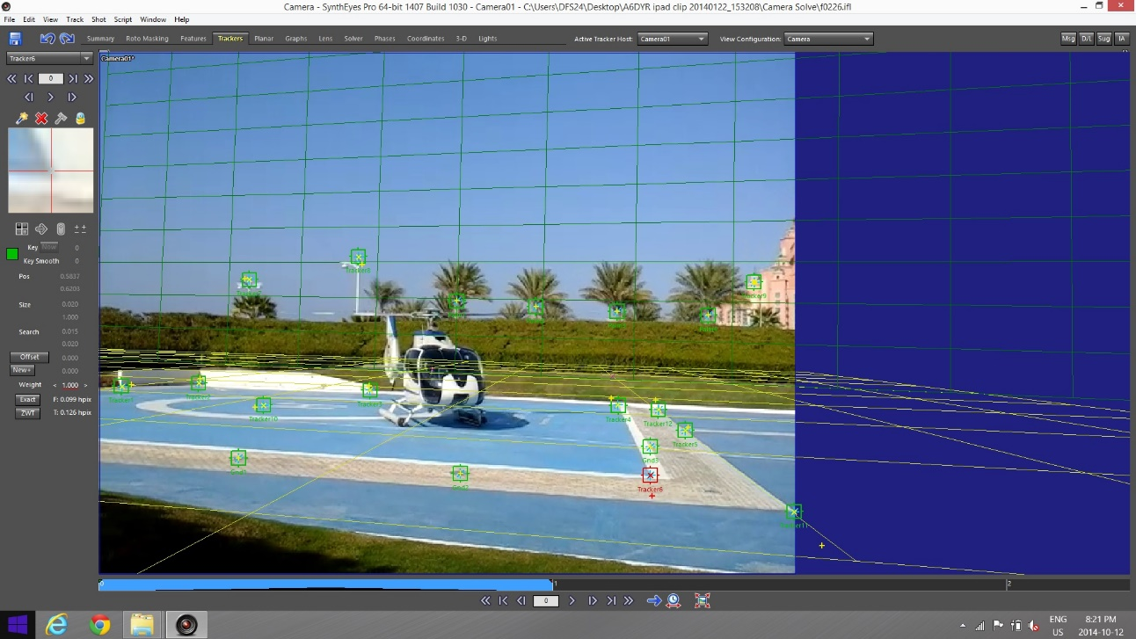

Adam Cybanski, BSc, IIC3
Gyro Flight & Safety Analysis

Video Velocity Analysis Investigation Report

Overview
- In 2014, a helicopter lost control during take-off. There was no flight data recorder installed, but the accident was captured by a witness on an iPad tablet. By analyzing the video of the aircraft within the context of its surroundings, the helicopter’s motion could be quantified, resulting in flight path data for the investigation including rate of climb/descent, maximum altitude, rate of turn, pitch, roll and other relevant parameters.

Background
- As an aircraft and traffic accident investigator, the author has been extracting velocity information from witness video since 2008. Cockpit cameras, dash cameras, ramp cameras, traffic cameras, and handheld witness video have been photogrammetrically analyzed in order to derive the velocities of the cameras, and the vehicles seen within the camera’s field of view. The crash of TransAsia Flight 235 in February 2015 was caught on three separate dash cameras, and marked the transition from aircraft to ground vehicle analysis. That year, the author also started assisting local police with investigations of traffic accidents that were caught on video. The techniques developed for analyzing velocities from video have been employed to support both traffic accident and aircraft accident investigations.
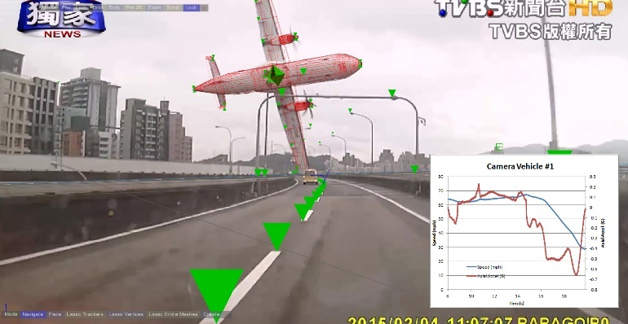
Figure 1 TransAsia 235 analysis

- Velocity analysis from witness video is based on three workflows: matchmoving, geolocation and time-distance analysis. Matchmoving is the determination of camera movement and object tracking from video. Geolocation involves identifying points from the video in real world coordinates (lat/long, UTM grid). Time-distance requires analysis of video frame timings and consolidation with distances to calculate velocities.
- Matchmoving is a process in film-making which aims to insert computer graphics into live-action footage with correct position, scale, orientation and motion relative to the background image. This has the effect of making the CGI content blend seamlessly into the live footage, but requires careful photogrammetric analysis of the video using special software. Analysis is used to determine exactly where the camera was in 3D space, what its orientation was, and the 3D location of any objects of interest.
- Geolocation involves the designation of identifiable features in video, and determining measured coordinates for them based on their real-world location. Sources for this data are typically surveys made onsite, but resources such as Google Earth can be used in their place. The aim of this information is to help the software determine the scale of the scene under analysis, and the relative location of the identifiable features so that it can orient a virtual camera correctly to match the actual camera that took the original image.
- The end result of geolocation and matchmoving is typically position and distance information. Analysis of video can yield up to 30 measurements per second, and the timing between each measurement is not always linear. Using additional analysis, a precise estimation on each image's time must be calculated, then combined with derived distances to yield velocities. The resulting data then undergoes statistical techniques in order to produce integrated plots of the velocities over time.

Incident

- The subject of this analysis was a Loss of Control Inflight [LOC-I] of a Eurocopter EC-130-B4 in 2014. The crew for this particular flight was a handling pilot and a helicopter landing officer. The helicopter picked up into a climb while rotating counter clockwise to the left. The climb was arrested at approximately 15-25 meters [50-75 feet] AGL, then the helicopter descended rapidly, pitching forward while in a continued counter-clockwise left-hand turn prior to an abnormal contact with the helipad and subsequent heavy landing.

- The helicopter contacted the helipad with a high rate of descent, and there was extensive damage to the primary and secondary structure and the dynamic components. Both the pilot and the passenger were incapacitated immediately following the helipad contact. The aircraft remained on the helipad for five minutes rotating down the heliport, until reaching a curb edge where the aircraft came to a full stop position. The helipad ground crew were then able to shut down the engine and assist with removal of the incapacitated crew.

- Video was taken by a ground observer with an iPad 2 tablet. It showed a helicopter on the helipad, pulling into a hover while turning left. The rate of turn increased when the helicopter started descending, and the video stopped just before the aircraft made contact with the ground. The video was MPEG-4 at 720x480 resolution, and included 48kHz audio. The video, only lasting 21 seconds, was recorded at 30.007 frames per second, which was decomposed into 640 separate images for analysis.

Geolocation

- The first step in the video analysis was to ignore the helicopter and track the movement of stationary ground references, such as helipad markings, trees, parts of a hotel hotel, and light stanchions. This was needed so that the software could determine the movement of the camera itself with respect to position (latitude, longitude, altitude) and orientation (tilt, pan roll). Small squares called trackers were positioned on the identifiable features, and adjusted in each frame of video so that they remained perfectly centered on the features while they were visible in the video.

- Features that might be visible in Google Earth such as landing pad markings were singled out in the video. These same features were identified in Google Earth perspective view where possible, and thumbtacks were placed in the Google Earth scene. When viewed from above, these thumbtacks could be positioned on the features with even greater accuracy, then the latitude and longitude of each feature was precisely transcribed.
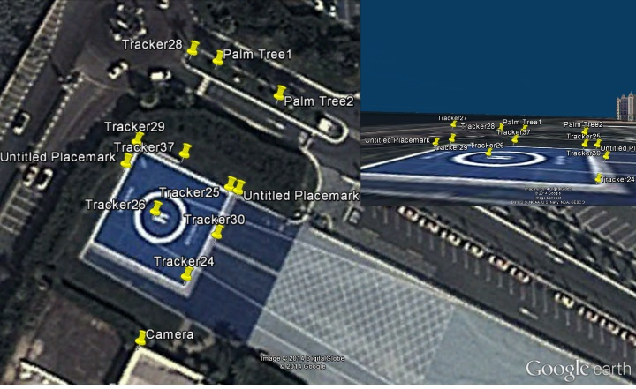
Figure 2 Feature coordinates from Google Earth

- The feature coordinates were imported into the software SynthEyes, which was able to use these coordinates to solve the camera for each frame of video that the ground could be easily seen. This included deriving the camera’s latitude, longitude, height above ground, heading, pitch, roll and focal length. Once the detailed camera information was calculated, a ground plane was placed on top of the helipad coordinates. The ground plane was used to interpolate the position of features that were not visible in Google Earth (such as marks on the pad), which would be useful for tracking when other objects left the field of view.

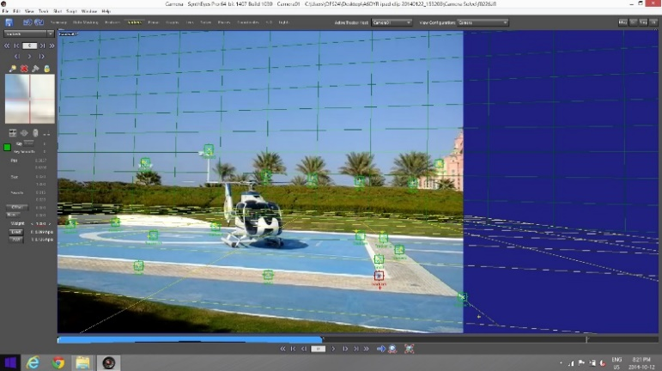

Figure 3 Background track

- For tracking features that were not located on the ground, an estimate of their height was needed. A photograph of an investigator standing next to a light stanchion was used to extrapolate an estimate of the stanchion height. To estimate the height of the trees, a vertical plane was placed along the tree line path, and the tree trackers were projected onto this plane, revealing their height and location. Once the aerial features were identified, they were useful for tracking movement of the camera, even when the ground features were not visible.

- In order to estimate the camera movement when few if any background features were visible, the camera movement rates before and after the loss of these reference features were extrapolated. This produced a comprehensive solution of the camera position and orientation for the full duration of the video clip. This information is needed before the analysis of any moving objects in the video can commence.

Object Tracking

- Next, prominent features on the helicopter were tracked. Points on the skids, fuselage and tail were identified and adjusted, frame by frame, producing a cohesive point cloud model of the aircraft. Many of the trackers were only visible for a short duration, but the large number of trackers allowed the software to determine the object orientation and relative position for each frame of video.
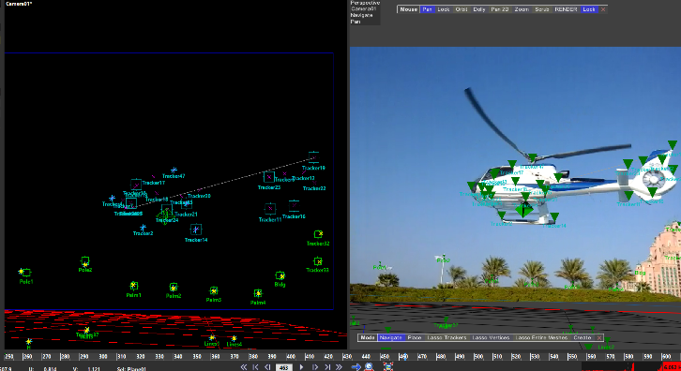
Figure 4 Helicopter Point Cloud

- Although the software understood the scale of the scene, based on the Google Earth coordinates, it didn't know the helicopter scale: was it very small and close to the camera, or huge and far away? The distance from the tail to the nose was taken from an engineering diagram and used to scale the helicopter in the scene. The software also didn't know which way was forward, and which way was up for the helicopter, so a coordinate system was identified with the xy plane being the plane that connects the four corners of the skids. The z axis was the line perpendicular to the skids, that went through the rotor mast. The y axis was on a vertical plane that went through the nose of the helicopter. With this coordinate system in place, analysis of the helicopter motion could start.

- With a scale and designated coordinate system for the moving object, the software could figure out its position and orientation in 3D space. Refining the previous camera-based solution, the aircraft track was calculated, producing the movement of the helicopter in space, with latitudes, longitudes, altitudes, pitch, bank and headings for the object (helicopter) for the duration of the video. These values were subject to small pixel error fluctuations because of minor camera shake and limitations in resolution. As the values were continuous over time, cubic spline interpolation was used to produce collective path and orientation data on the aircraft. The result was flight path data on the aircraft very similar to what is produced by a flight data recorder.

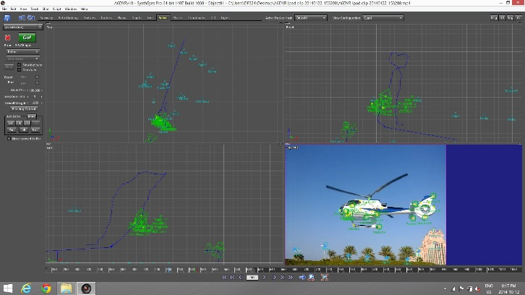
Figure 6 Derived Flight Path

Validation

- For velocity extraction from video, the best way to validate the derived flight path data is to film a simulator visualization of the data from a location identical to where the actual video camera filmed the event. Once this is recorded from the simulator, it can be played side-by-side with the original real accident video, frame-by-frame to ensure that the visualization and actual aircraft flight match perfectly. Once this is done successfully, the data is considered validated. The data from this accurate representation of the aircraft's flight profile, can then be analyzed. If the vehicle movement between the two images do not match, it is indicative of problems, and further work is required. In this case, there was a very strong correlation between the video and the animation.

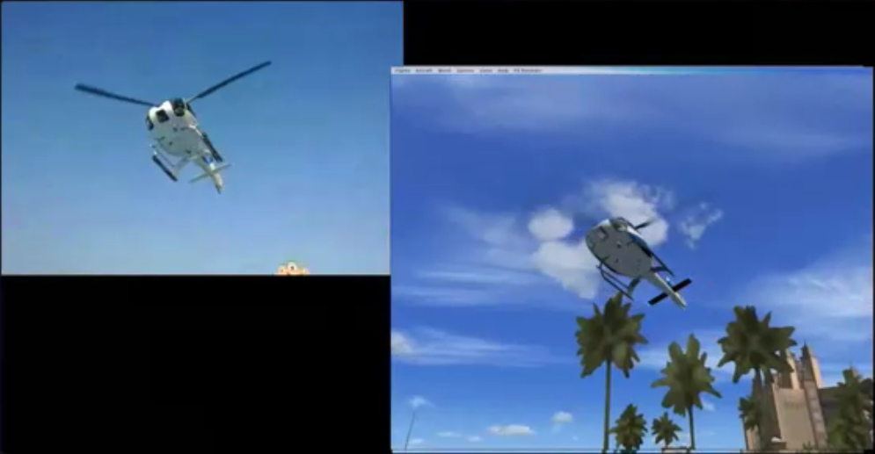
Figure 7 Original video and animation comparison

Data Analysis

- With the derived flight data validated, information critical to the investigation could be derived from the aircraft flight data. This included maximum altitude, maximum rate of climb, maximum rate of descent, maximum turn rate, number of revolutions, turn rate and descent rate on ground contact, lateral movement, vertical acceleration, maximum pitch and roll. From these parameters, power changes and control movements could be inferred.
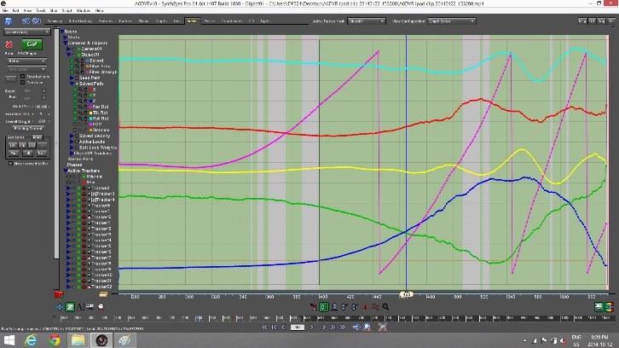
Figure 5 Graphic Flight Parameters

Visualization

- In addition to flight path data analysis, visualization of the subject occurrence from other perspectives is also useful. Using the calculated object position and orientation data, a visualization of the aircraft’s flight path was produced in a flight simulator. A replay of the accident from the virtual cockpit showed investigators what the visual references were like for the pilot, and how much reaction time they had. Visualizations from witness locations could be shown to accident witnesses, to validate the derived flight data. Tower camera, chase, overhead, and reverse views can make the flight path and surrounding environment easy to understand, and support the accident investigation.

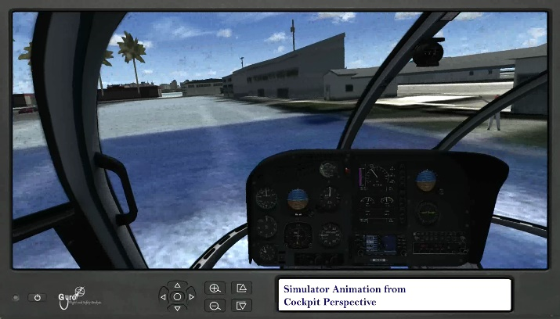
Figure 8 Visualization from pilot perspective

Findings
- Over the course of this video analysis, several things were found based on witness camera video footage of this accident:
  - Analysis of the iPad witness video suggested that the helicopter climbed to a maximum height above ground of 72 feet (22 metres) at the 10 second mark.
  - The maximum rate of rotation was 258° per
second at the 8.6s mark. The rate was 166° per second at the point of impact.
  - Immediately prior to impact, the rate of descent was 2400 feet per minute.

Conclusions
- An iPad is not a high-precision instrument, but a low-cost imaging device easily accessible to the general public. The limited resolution of 720x480 of the video and lack of background references when the helicopter was high up made it challenging to track its height and vertical speed during that portion of the flight. Even with these limitations, a readily available consumer tablet was able to capture precise high-resolution velocity data from the image sequence. Witness camera video velocity analysis has proven to be a precise and useful capability for the modern accident investigator.
- In this technological age, it is likely that an aircraft accident will be captured on a cockpit camera, cell phone or security camera. In the absence of a flight data recorder, or to validate it, the video can be analyzed to derive the aircraft flight path and parameters. This flight data can be invaluable in the accident investigation. The data can also be used to produce visualizations of the flight in a flight simulator. These visualizations can place the investigator at the scene of the accident, or even in the cockpit while the accident takes place. It is amazing the amount of valuable investigation support that can be extracted from a simple handheld video. Video has typically been seen as qualitative evidence for traffic accident collision reconstruction. This and previous testing has shown that when properly analyzed, video can reveal accurate quantitative data as well.

Video Forensic Examiner
- The video forensic examiner and author of this report is Mr Adam Cybanski, a qualified accident investigator and video velocity specialist that has been leading the industry in analysis of video for velocity for accident investigation. Mr Cybanski holds a BSc in Computer Mathematics and gained his Investigator In Charge level 3 in 2012 at the Directorate of Flight Safety in Ottawa, Canada. Throughout his years of experience Mr Cybanski worked on velocity and motion extraction from video on a professional level within the aircraft and traffic accident investigation communities for international accident investigation agencies. He has been recognized in court as an expert in the field of Video Velocity Analysis. In addition to his work with Gyro Flight and Safety Analysis, Mr. Cybanski is a reservist at the rank of Major with the Royal Canadian Air Force, and teaches regularly at the University of Southern California Viterbi School of Engineering Aviation Safety & Security Program on their Data for Safety Management and Safety Management Systems for Remotely Piloted Aircraft courses.
- Gyro Flight and Safety Analysis provides expert video analysis and accident reconstruction services in the areas of video forensics and velocity extraction from video. Based in Ottawa, Canada, it offers an impartial, independent and specialised service to police, military and civilian prosecution and defence. The company adheres to a strict non-disclosure policy in relation to all case files worked on and abide by the APCO guidelines and the Data Protection Act 1998.

A. Cybanski
BSc, IIC3
CEO Gyro Flight & Safety Analysis
cybanski@gyrosafety.com

